

PANGANI GIRLS’ KCSE PREDICTION
EXAM TEST-2025
232/2
PHYSICS
PAPER 2
TIME: 2 HOURS

NAME…………………………………………………………………………………………
SCHOOL………………………………………………. SIGN……………………..
INDEX NO ……………………………………………. DATE…………………….

Kenya Certificate of Secondary Education.

Instructions to candidates
(a) Write your name, index number in the spaces provided above.
(b) Sign and write the date of the examination in the spaces provided
(c) This paper consists of TWO Sections: A and B.
(d) Answer ALL the questions in section A and B in the spaces provided.
(f) KNEC mathematical tables and silent non-programmable electronic calculators may be used.

For examiners use only
Section | Question | Maximum score | Candidates score
A | 1-13 | 25
B | 14 | 13
 | 15 | 11
 | 16 | 11
 | 17 | 10
 | 18 | 10
 | TOTAL SCORE | 80

SECTION A: 25marks
Answer ALL the questions in this section in the spaces provided
1.The figure below shows region of the complete electromagnetic spectrum. (2 marks)
 |  |  | Red |  | Violet
 | A |  |  | Visible light |  |  | B | C

i) Name the region marked A and B. (2 marks)
A ……………………………………….
B ……………………………………….
ii) State one use of electromagnetic radiation marked C. (1 mark)
…………………………………………………………………………………………………………………………………………………………………………………………………………

2.The figure shows circular waves approaching a place barrier in uniform medium.

On the diagram draw the reflected waves. (1 mark)

3. A student standing between two cliffs and 500m from the nearest cliff clapped his hand and heard the first echo after 3 seconds and the second echo 2 sesconds later. Calculate the distance between the cliffs. (3 marks)
………………………………………………………………………………………………………………………………………………………………………………………………………………………………………………………………………………………………………………………………………………………………………………………………………………………

4. The figure below shows a hollow negatively charged sphere with a metallic disc attached to an insulator placed inside.
State and explain what would happen to the leaf of uncharged electroscope if the metallic disc was brought near the cap of the electroscope. (2 marks)
…………………………………………………………………………………………………………………………………………………………………………………………………………………………………………………………………………………………………………………………………………………………………………………………………………………………………………

5.Explain how local action is reduced in a simple cell. (1 mark)
…………………………………………………………………………………………………………………………………………………………………………………………………………………………………………………………………………………………………………………
6. Figure shows the graph of image distance v against the object distance u for a curved mirror.

a) Explain why the coordinate P is for a magnified image. (1 mark)
…………………………………………………………………………………………………………………………………………………………………………………………………………………………………………………………………………………………………………………
b) Identify the type of mirror used. (1 mark)
………………………………………………………………………………………………………

7. Radio waves travel with a speed of 3.0 x 10⁸ m/s in air. If a broad casting station broad casts at a wavelength of 225m, calculate the period of the radio waves. (2 marks)
………………………………………………………………………………………………………………………………………………………………………………………………………………………………………………………………………………………………………………………………………………………………………………………………………………………

8.Two parallel current carrying conductors are placed close to each other as shown in figure below.

On the same diagram, draw the magnetic field pattern and indicate the directions of the forces experienced by each conductor. (2 marks)

9. Figure shows a stationary wave.
a) Identify an antinode in the diagram. (1 mark)
………………………………………………………………………………………………………
b) What is the wavelength of the stationary wave? (1 mark)
…………………………………………………………………………………………………………
10. Figure shows a needle fixed on a cap of a leaf electroscope. The electroscope is highly charged and then left for some time.
Explain why the leaf collapses. (2 marks)
………………………………………………………………………………………………………………………………………………………………………………………………………………………………………………………………………………………………………………………………………………………………………………………………………………………

11.The diagram below shows two mirrors inclined at 60º to each other. (Not drawn to scale)

Sketch on the diagram the path of the ray after striking mirror AB (2 marks)

12.A soft iron ring is placed between two poles of permanent magnets as shown below. Draw the magnetic field pattern set up between the two poles. (1mark)
N N S
S S

13.Explain how hammering in the E-W direction demagnetizes a magnet (1 mark)
…………………………………………………………………………………………………………………………………………………………………………………………………………………………………………………………………………………………………………………

SECTION B: 55marks
Answer ALL the questions in this section in the spaces provided
14.a) A lens forms a clear image on a screen when the distance between the screen and the object is 100. If the image is 4 times the height of the object. Determine;
i) The distance of the image from the lens. (3 marks)
………………………………………………………………………………………………………
………………………………………………………………………………………………………
………………………………………………………………………………………………………
………………………………………………………………………………………………………
………………………………………………………………………………………………………
………………………………………………………………………………………………………

ii) The focal length of the lens. (2 marks)
………………………………………………………………………………………………………
………………………………………………………………………………………………………
………………………………………………………………………………………………………
………………………………………………………………………………………………………
………………………………………………………………………………………………………

b) The graph below shows the variation of 1/v and 1/u in an experiment to determine the focal length of a lens.
0.1
0.3
0.3
0.1
0.2
0.3
$\frac{1}{u}$ m⁻¹
$\frac{1}{v}$ m⁻¹

- Use the graph to determine the focal length (2 marks)
………………………………………………………………………………………………………
………………………………………………………………………………………………………
………………………………………………………………………………………………………
………………………………………………………………………………………………………

(ii) What is the power of the lens used? (1mark)
…………………………………………………………………………………………………
…………………………………………………………………………………………………
c) The diagram below shows an upright object O placed in front of a concave lens.
F
o
pp

By use of rays, locate the position of the image formed. (2 marks)
(e) The figure below shows a human eye with a defect.
Eye Ball
near object
Image
Eye lens

(i) Name the defect ……………………………………………………… (1mark)

- State one possible cause of the defect
(1mark)
………………………………………………………………………………………………………………………………………………………………………………………………

(iii) Name an appropriate lens that can be used to correct this defect. (1mark)
............................................................................................................................................................................................................................

15. (a)The figure below shows part of the lighting circuit of a house.

i)Explain why a fuse is included in the circuit. (1 mark)
………………………………………………………………………………………………………
………………………………………………………………………………………………………
………………………………………………………………………………………………………

ii) Explain why the fuse is placed in the live wire rather than in the neutral wire. (1 mark)
………………………………………………………………………………………………………
………………………………………………………………………………………………………

b)A house has five rooms each with 240V, 60W bulbs. If the bulbs are switched on from 7:00pm to 11:00pm,
i) Calculate the power consumed per day in kilowatt-hour. (3 marks)
………………………………………………………………………………………………………
………………………………………………………………………………………………………
………………………………………………………………………………………………………
………………………………………………………………………………………………………
………………………………………………………………………………………………………

ii) Find the cost of power per week for lighting these rooms at Ksh. 6.70 Per unit. (2 marks)
………………………………………………………………………………………………………
………………………………………………………………………………………………………
………………………………………………………………………………………………………
………………………………………………………………………………………………………

iii) Each lamp has a power of 60W. Calculate the current through one lamp when it is switched on. (2 marks)
………………………………………………………………………………………………………
………………………………………………………………………………………………………
………………………………………………………………………………………………………
………………………………………………………………………………………………………

c) Explain why long distance power transmission in done at a very high voltage (2 marks)
………………………………………………………………………………………………………
………………………………………………………………………………………………………
………………………………………………………………………………………………………
………………………………………………………………………………………………………

- (a) State Farady’s law of electromagnetic induction. (1mark)
........................................................................................................................................................................................................................................................................................................................................................................................................................................................................
(b) Figure below shows an experiment to illustrate electromagnetic induction using a coil and a magnet.
Magnet
N S

State the observation on the galvanometer when:
i) The magnet is stationary (1 mark)
………………………………………………………………………………………………………
………………………………………………………………………………………………………
………………………………………………………………………………………………………

ii) The magnet is plunged into the coil at constant velocity (1 mark)
………………………………………………………………………………………………………
………………………………………………………………………………………………………
………………………………………………………………………………………………………

iii) Explain how the current is produced. (2 marks )
………………………………………………………………………………………………………
………………………………………………………………………………………………………
………………………………………………………………………………………………………
………………………………………………………………………………………………………

iv) Show on the diagram the direction of the current in the coil when the magnet is moved towards the coil (1 mark)
(c) A transformer is designed to supply a current of 12A at a P.d. of 80V. The inlet cable is to be connected to an a.c. mains of 240V. The efficiency of this transformer is 80%.
Calculate:
(i) Current in the primary coil of the transformer (2marks)
……………………..…………………………………………………………………………………………………………………………………………………………………………………….............................................................................................................……………………………………………………………………………………………………………
(ii) The power supplied to the transformer (2marks)
………………………………………………………………………………………………………………………………………………………………………………………………………………………………………………………………………………………………………………………………………………………………………………………………………………………
(iii) Explain how energy losses in a transformer are reduced by having a soft iron core.(1mark)
…………………………………………………………………………………………………………………………………………………………………………………………………………………………………………………………………………………………………………………

17. (a)The figure below shows a simple electric motor running on battery.
- Label parts; A and B
( 2marks)
A………………………………………
B……………………………………….

(ii) Indicate the poles of the magnet on the diagram so that the coil rotates in the direction indicated. (1 mark)

- Suggest two improvements that could be made on the motor to improve its efficiency.
(2 marks)
……………………………………………………………………………………………………………………………………………………………………………………………………………………………………………………………………………………………………………………………………………………………………………………………………………………

b) i) State one condition for Ohm’s law to hold (1mark)
……………………………………………………………………………………………………………………………………………………………………………………………………………

ii) The graph below shows a voltage-current graph for a cell.

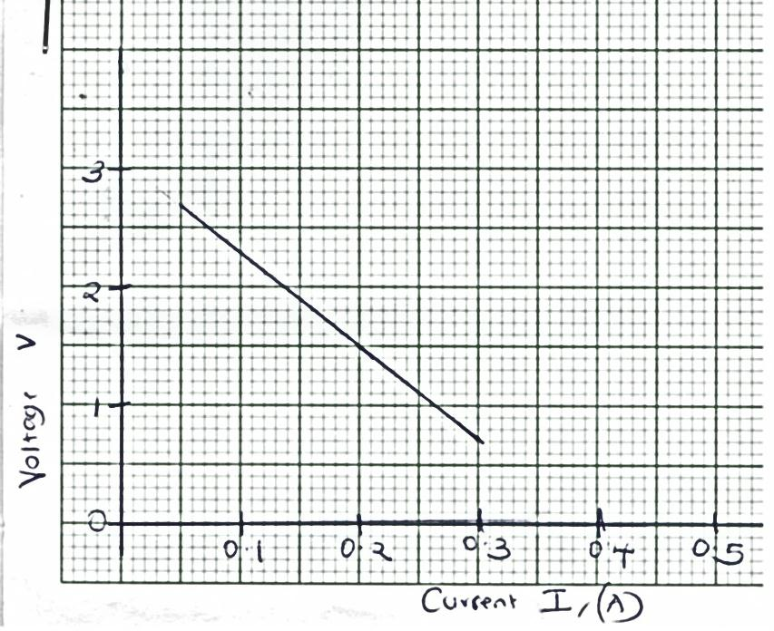
VOLTAGE, V
CURRENT, I (A)
Determine;
- The e.m.f of the cell. (1 mark)
………………………………………………………………………………………………………
………………………………………………………………………………………………………
………………………………………………………………………………………………………

ii) The internal resistance of the cell given that E = V + Ir (3 marks)
………………………………………………………………………………………………………
………………………………………………………………………………………………………
………………………………………………………………………………………………………
………………………………………………………………………………………………………
………………………………………………………………………………………………………
………………………………………………………………………………………………………
………………………………………………………………………………………………………

18.a) Figure shows how light is dispersed to produce a rainbow when it passes through a raindrop.

State with reasons, what is happening to the ray of light at points.
- Q (2 marks)
………………………………………………………………………………………………………
………………………………………………………………………………………………………
………………………………………………………………………………………………………
………………………………………………………………………………………………………
………………………………………………………………………………………………………

- R (2 marks)
………………………………………………………………………………………………………
………………………………………………………………………………………………………
………………………………………………………………………………………………………
………………………………………………………………………………………………………
………………………………………………………………………………………………………

b) Three capacitors are connected as shown in figure 9 below with a battery of e.m.f 6V and zero internal resistance.
2μF
1μF
12μF
Calculate the;
i) Effective capacitance. (2 marks)
………………………………………………………………………………………………………
………………………………………………………………………………………………………
………………………………………………………………………………………………………
………………………………………………………………………………………………………

ii) Charge on the 12μF capacitor. (2 marks)
………………………………………………………………………………………………………
………………………………………………………………………………………………………
………………………………………………………………………………………………………
………………………………………………………………………………………………………

iii) State two factors that increases capacitance of parallel plate capacitor. (2 marks)
………………………………………………………………………………………………………
………………………………………………………………………………………………………

